A Point Within A Circle

By Wor. Matt Duley

Freedom Lodge No. 118

After I became an Entered Apprentice, I speculated that the combined symbols of a point within a circle and the pillars we see today are an allusion to the secret knowledge of the Operatives.

I speculated further that there is much more to the pillars than we are told, but I will save that fascinating topic for another lecture.

In reading about Operative Masonry and the construction of Cathedrals, I came upon something amazing which I will now share with you.

[Note: For maximum effect, the presented lodge program should demonstrate each step seen in Figure 244, followed by removal of design elements to leave a point within a circle touching two parallel lines]

[Note: The next two pages and a graphic on the last page are from “Cathedrals Built by the Masons” by Schiffler].

The image above immediately recalled to my mind the “point within a circle” we hear so much about. In the Entered Apprentice degree we are informed that:

“Our ancient Brethren dedicated their Lodges to King Solomon, who was our first Most Excellent Grand Master; but Masons professing Christianity, dedicate theirs to St. John the Baptist and St. John the Evangelist, who were two eminent Christian patrons in Masonry; and since their time there is represented in every regular and well-governed Lodge a certain point within a Circle, embordered by two perfect Parallel Lines, representing St. John the Baptist and St. John the Evangelist, and on the top rests the Book of Constitutions. In going round this Circle we necessarily touch upon those two Parallel Lines as well as the Book of Constitutions; and while a Mason keeps himself circumscribed within their precepts, it is impossible he can materially err.” – Presentation Volume; Manual of Work (2017)

So now if we go back to our previous diagram and *remove* some crucial aspects of the design, we will see that we are left with a “point within a circle” and one of the true natures of the symbol is again *concealed*. But it’s enough of a reminder on how to proceed for those with this knowledge.

Thus, I believe that I have shown you a transition directly from Operative to Speculative Masonry. Accordingly, I now present Freedom Lodge with this representation,

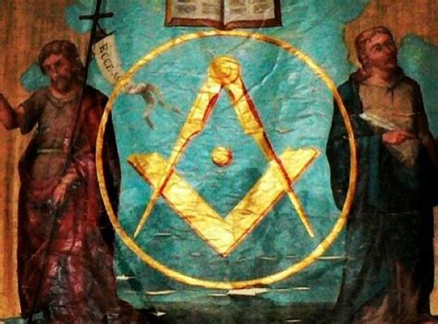

in hopes that all who enter the doors of this Lodge will reflect on and apply the lessons they are taught herein.

Maybe this Operative image, posited to covey architectural clues about how flying buttresses are constructed will spur your imagination to identify other links between Operative and Speculative Masonry.

