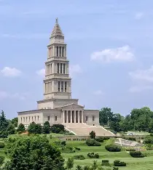
Freedom Lodge and the Establishment of the George Washington Masonic
National Memorial
By Matt Duley, PM

Introduction
During our Lodge Fellowship day in 2026, we came across some certificates that were badly aged as their frames had been destroyed from being tossed in closets instead of being displayed. I decided to do some research on these certificates and share with you what I found.
Historical context
While several lodges were in possession of assorted relics and mementos of George Washington, after his death a tremendous amount more was gifted to Alexandria-Washinton lodge. It wasn’t until 1802 that they had a dedicated space to meet, which was in the City Hall. “Indeed so numerous were the gifts and so much space did the collection occupy…” in 1818, “the City Council appropriated the entire third story of one wing” to be used as a museum. Unfortunately, in May of 1871, the City Hall was destroyed by a fire and much of the collection was lost. “Most of the furniture, all the records, the original portrait of Washington by Williams, the Master’s chair that had been occupied by Washington in 1788 as presiding officer, and a number of other relics and paintings were saved. A listing of items destroyed can be found in the book “George Washington | Masonic Life” by Callahan. An interesting footnote remarks that “It is believed that the military saddle of Washington and the bier upon which he was borne to the tomb were not destroyed by fire. They mysteriously disappeared, however, and have not been recovered.”
In 1892, Freedom Lodge No. 118 was rechartered after an earlier period as No. 199
In 1909 William Howard Taft was made a Mason “at sight” by the Grand Master of Ohio shortly before Taft became president.
Alexandria-Washington lodge took the initiative to “inaugurate a national movement to erect a memorial to Washington, the Mason and thereby preserve in a fireproof repository these sacred treasures, as a legacy for future generations of Masons and the glory of our national institution.” On the anniversary of Washington’s celebrated birthday in 1910, what we know today as the George Washington Masonic National Memorial Association was established.
In the minutes of the 1913 Grand Lodge of Virginia proceedings, I found a description of the effort. Note: back then, Grand Annual Communication was held in February.
1913: - VIRGINIA - Masonic Grand Lodge Proceedings
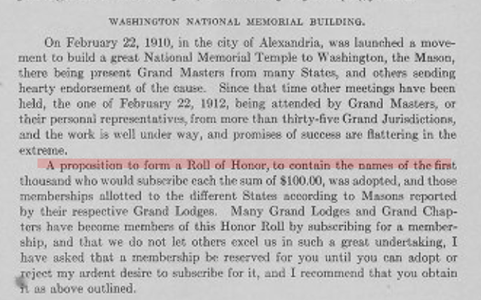
While $100 may not sound like much, adjusting for inflation, $100 in 1913 is roughly equivalent to about $3,100–$3,300 today (2026).
Above we see that the proposition to establish the Roll of Honor was adopted in 1912.
It appears that the Roll of Honor was going to exist only for a short time as “The convention had by approval of the minutes of the Convention of 1912 voted to close The Charter Roll of Honor on January 1 of 1913, but they decided to extend it for a year based on a motion of Past Grand Master McChesney of Virginia.”
In my research, I found in the minutes of the GWMNMA that President William Howard Taft attended the 1913 meeting:
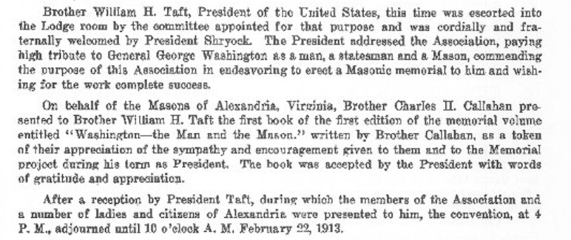
As a matter of pure coincidence, for my birthday this year, my wife Ashley gifted me a copy of the 1913 book by Callahan, which aided my research!
From what I have been able to discern through my online research, Freedom Lodge No. 118 appears in The George Washington Masonic National Memorial Association Charter Roll of Honor for the years 1913, 1914, and 1915.
Why These Years Matter
During this short period:
- The modern U.S. financial system was established
- Federal regulatory power was strengthened
- In March of 1913, Wilson succeeded Taft as President
- War began in Europe in July 1914 after the assassination of Archduke Franz Ferdinand
- In August, the US declared neutrality under President Wilson.
- 1915 was the sinking of the Lusitania
- The stage was set for U.S. entry into World War I in 1917
Freemasonry in the United States, 1900-1930.
After the Morgan Affair and the period of anti-Masonic sentiment from 1820-1840, the Craft began to rebuild and shifted from an elite fraternal organization to one more firmly rooted in middle-class culture, which was burgeoning at that time. At the turn of the twentieth century, Freemasonry still was a way for middle-class men to escape and enjoy comradeship with others sharing similar ideals and outlook. The Masonic temple was a space secluded from the world they engaged in daily. It was a place where they participated in ritual, and were entertained and educated, independent of their wives and families. Besides being an escape from what was understood to be a profane world, the Masonic temple was also a location where men tried to improve themselves morally through ritual and education. Freemasonry emphasized a morality and proper behavior to its members that was firmly embedded within prevailing, late-Victorian middle-class ideologies.
Between 1900 and 1930, Freemasonry entered a significant period of change. As the nation grew and expanded economically, a younger generation found aspects of Freemasonry that had previously been a draw for prospective members antiquated or obsolete. Leisure time could be filled with any number of commercialized pursuits, such as theatres, nickelodeons, baseball games, and bars for entertainment. Widespread public secondary education and increased enrollment at colleges and universities provided vastly improved educational opportunities. To some, the moralistic code of Freemasonry of moderation and temperance was not appealing in an age that increasingly glorified consumption.
Still, even in this period of change, the number of men involved in Freemasonry continued to grow and would peak at over three million by 1930. A softening of the rules for induction and a shift in emphasis from moralism to patriotism counterbalanced the potential decrease in membership. What had been an insular fraternal organization became one having a larger external purpose. In the past, Freemasonry’s connection with the outside world was in having its members keep the three Masonic tenets—brotherhood, wisdom, and charity—an active part of their lives. This ideal was expanded and reinterpreted in the early decades of the twentieth century by younger freemasons who felt that Masonic tenets could be more concretely employed to help solve society’s problems. …
… To be a freemason in the early twentieth century not only meant an individual was respectable and had a good moral character, but also that he was a good citizen, active in the community, and committed to promoting American ideals of democracy, equality, and justice.
Of course, since Freemasonry was not a centralized fraternal organization, as the Rotarians were, there was no real consistency on how lodges promoted Americanism. Nonetheless, … the common thread of civic duty and participation provided a general framework for Freemasonry…
It was these elements of service, spreading interest in American history, and concepts of citizenship that appealed to the many of the men in this period and helped to keep an old institution modern and relevant to a younger generation.
What was District 2 like at the time?
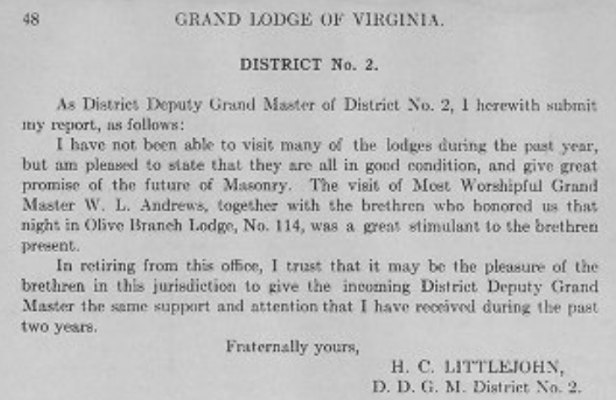
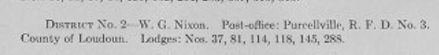
In 1913, what we know today as Hamilton-Thompson No. 37 had not yet merged. The District was composed of the following Lodges:
Hamilton Lodge No. 37
Salem Lodge No. 81 went inactive in 1939
Olive Branch Lodge No. 114
Freedom Lodge No. 118
Thomson Lodge No. 145
Ashburn Lodge 288 (In 1997, the lodge consolidated with Sterling Lodge No. 268)
So what was Freedom Lodge No. 118 like around that time?
According to Grand Lodge records from 1913, here is the roll:
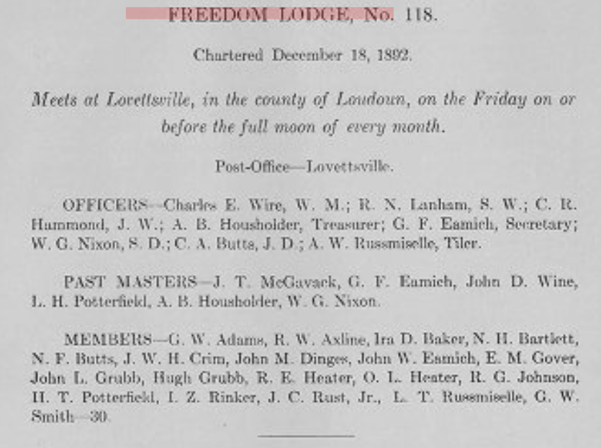

Freedom Lodge only had 30 members at that time and we paid $45 to Grand Lodge. We had one demit and raised one Master Mason: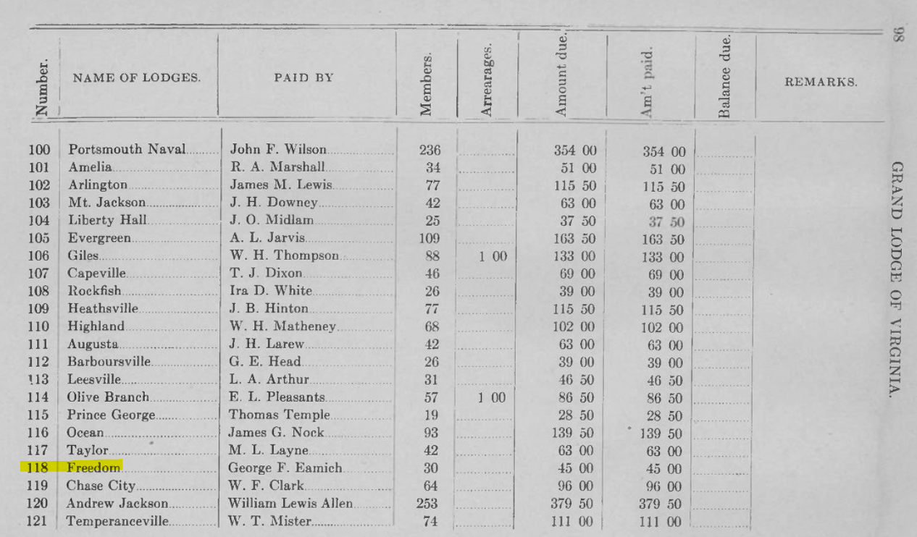
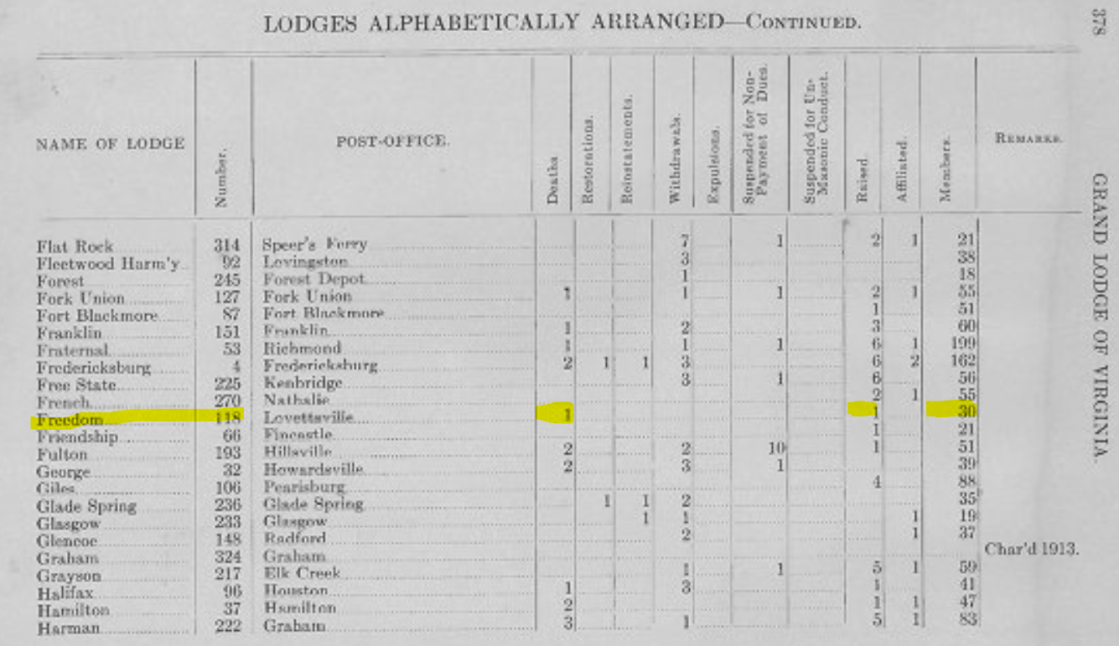

Presentation of reframed Certificates
The recently discovered certificates have been reframed by Wor. Matt Duley for display in Freedom Lodge No. 118 and it is hoped that this program will better inform our membership of its history. Photos of the certificates are attached on the following pages.
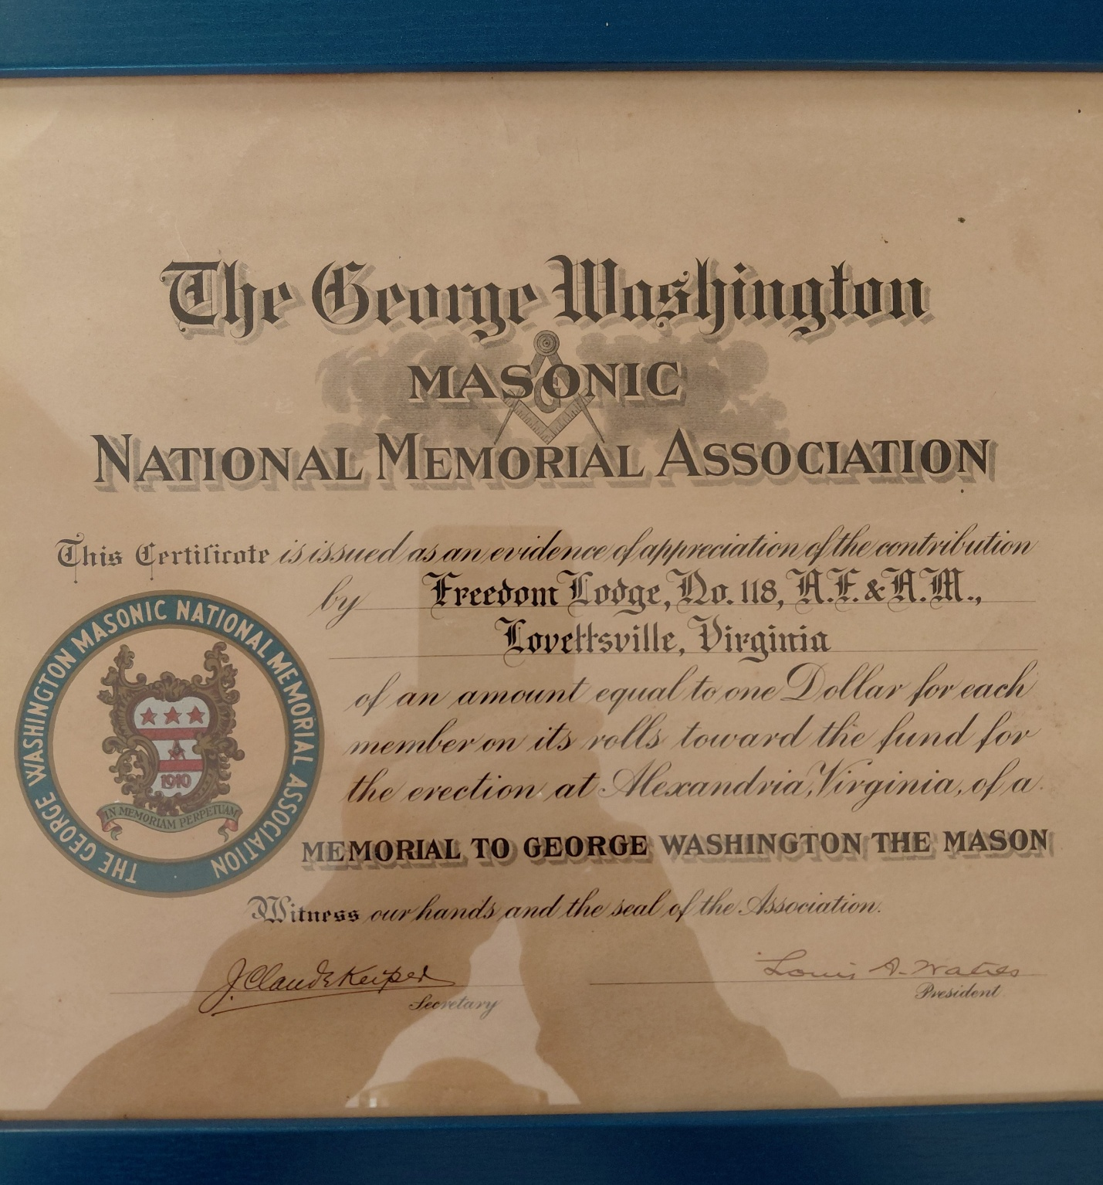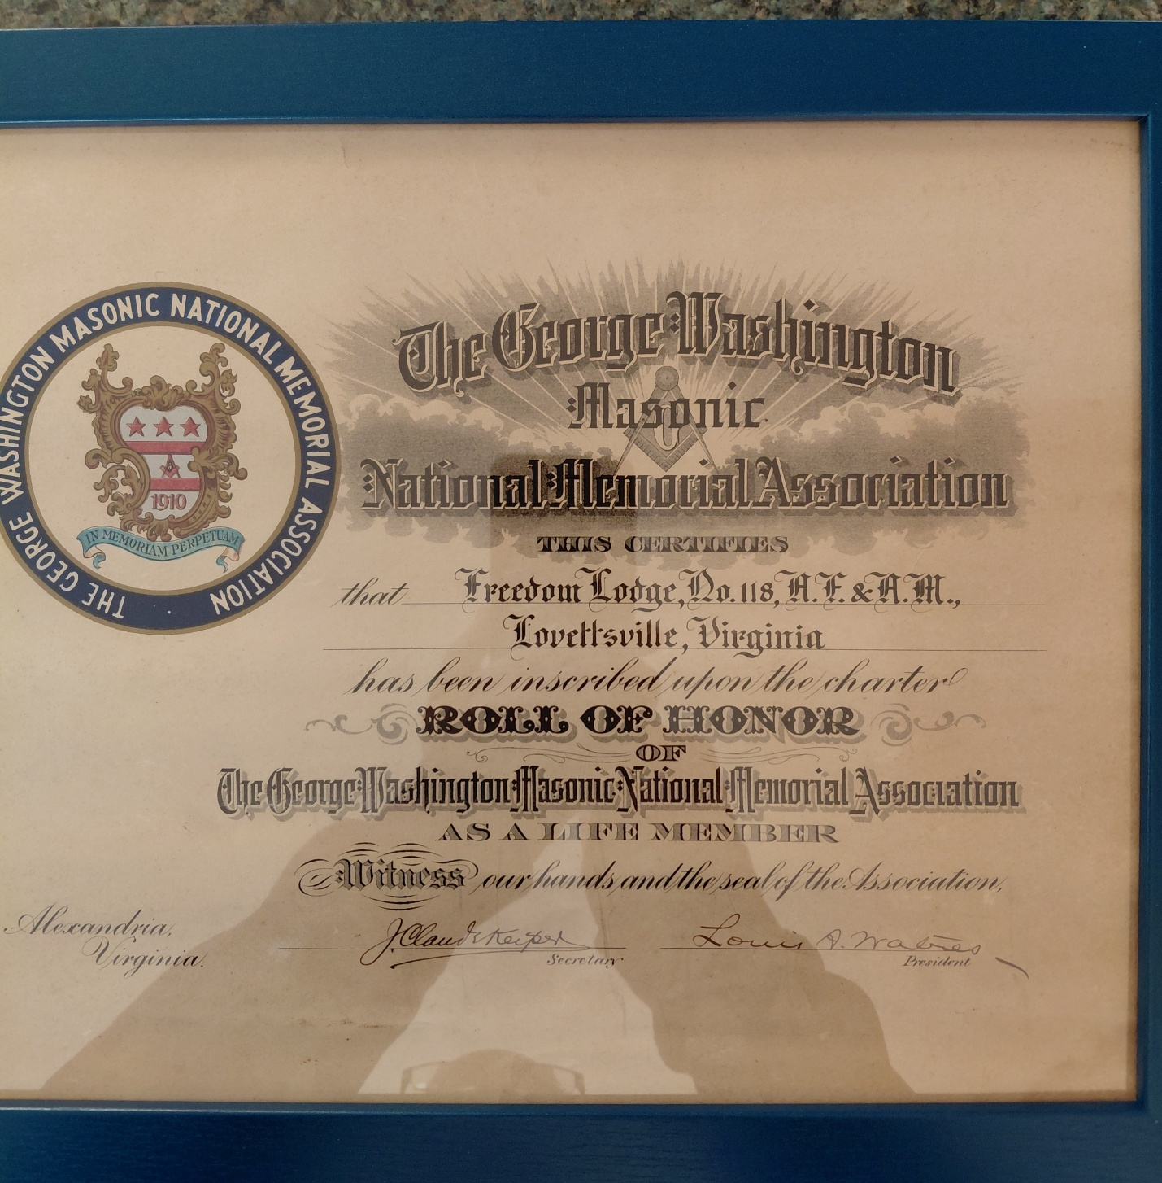

Research details on the contributions of Freedom Lodge No. 118
1913 Mintues: - GEORGE WASHINGTON MASONIC NATIONAL MEMORIAL ASSOCIATION - Annual Reports
Year | Section | Page Range | Status

1913 | Charter Roll of Honor | ~146–150 | Listed

1914 | Charter Roll of Honor | ~160–165 | Listed

1915 | Charter Roll of Honor | ~170–176 | Listed
1913 (PRIMARY SOURCE — CONFIRMED)
📍 Source
- GWMNMA Proceedings (Annual Convention)
- Page: Charter Roll of Honor section (approx. pp. 30–40 of report section; varies by scan)
📄 Extract (verbatim line)
“Freedom Lodge No. 118, Virginia”
🔎 Context
- Appears under Virginia in the Charter Roll
- Listed among lodges subscribing to the $100 life membership plan

⚠️ 1914 (PRIMARY SOURCE STATUS)
- The official GWMNMA archive does NOT currently include the 1914 proceedings volume
- This is why earlier historians rely on:
  - Grand Lodge reprints
  - or later summary listings
👉 However:
- Continuity between 1913 and 1915 rolls strongly supports inclusion
- The roll was reprinted annually, not recreated from scratch

✅ 1915 (PRIMARY SOURCE — CONFIRMED)
📍 Source
- GWMNMA Proceedings (1915 Annual Convention)
- Page: Charter Roll of Honor section (approx. pp. 40–55 depending on scan pagination)
📄 Extract (verbatim line)
“Freedom Lodge No. 118, Virginia”
🔎 Context
- Same formatting and placement as 1913
- Confirms continued inclusion in the Charter Roll

Final, Primary-Source-Supported Answer
Year | Status | Source Type
1913 | Confirmed | Original GWMNMA proceedings
1914 | Implied (gap in archive) | Missing primary volume
1915 | Confirmed | Original GWMNMA proceedings
George Washington Masonic National Memorial: Draft Nomination

Sources:
The George Washington Masonic National Memorial
George Washington Masonic Memorial
“George Washington | Masonic Life” by Charles H. Callahan
Primary source documents (the actual certificates, reframed)

